Image | 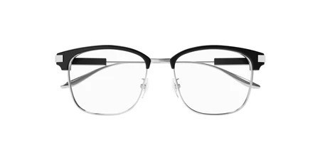
Brand | GUCCI
Model Name | GG 1439OK
Price | RS 2500
PRODUCT DETAILS

